Track Meet 3 – Saturday, May 6th, 2017
Field Event Finals – 3200 meter Finals – 100 m, 200 m, & 400 m Prelims

Top 15 - Field Events – 1:00 pm Start
Long Jump Shot Put Discus
8th Boys 7th Boys 8th Boys
8th Girls 7th Girls 8th Girls
7th Boys 8th Boys 7th Boys
7th Girls 8th Girls 7th Girls

3200 Meter Run – For Medals
Est. Start – 1:30 pm / First Call 1:20 pm
Preliminary Dashes – Approximate Start – 2:00 pm
100 Meter
200 Meter
400 Meter
“Challenge Race”

Junior High and High School Athletes from the Villa Marie School in Waverly, NE will participate in a 100 meter dash. Awards will follow.
Welcome Villa Marie Athletes!
This race will follow the 100 Meter Dash. The 200 and 400 Meter Dash will follow the Challenge Race.
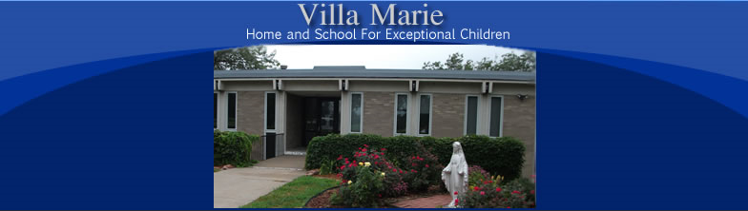

Villa Marie
Villa Marie Home and School for Exceptional Children serves qualifying students who are in need of special educational services. Located between Lincoln and Waverly, Nebraska in the beautiful countryside, is a peaceful and inviting setting, providing a loving, homelike atmosphere for both day students and boarders.

Lincoln Catholic Schools Track Meet

Thank you for your time and effort in making this a positive and exciting event for our students. We would like to remind you of a few rules for the meet:

- Only athletes and coaches are permitted on the track and infield area during the meet. This is for the safety of all involved. Remember, SAFETY FIRST!
- Track spikes are permitted, but not required. If worn, up to 1/4 inch spikes are allowed.
- There are to be NO shot puts or discus thrown or dropped on the football field. Keep all shot and disc competition on the upper field area where the shot and disc rings are. Spectators are to stand BEHIND the fence at the discus ring, and to the sides of the shot put rings. Remember, SAFETY FIRST!
- Coaches, please keep your athletes together in a central location somewhere within the stadium during the meet. This is for safety and for communication.
- Please pick up your garbage throughout the meet. We are guests of Pius, and the more that we can keep the facility clean, the more we will be able to use it.

